Countryfile Visits Knaresborough!
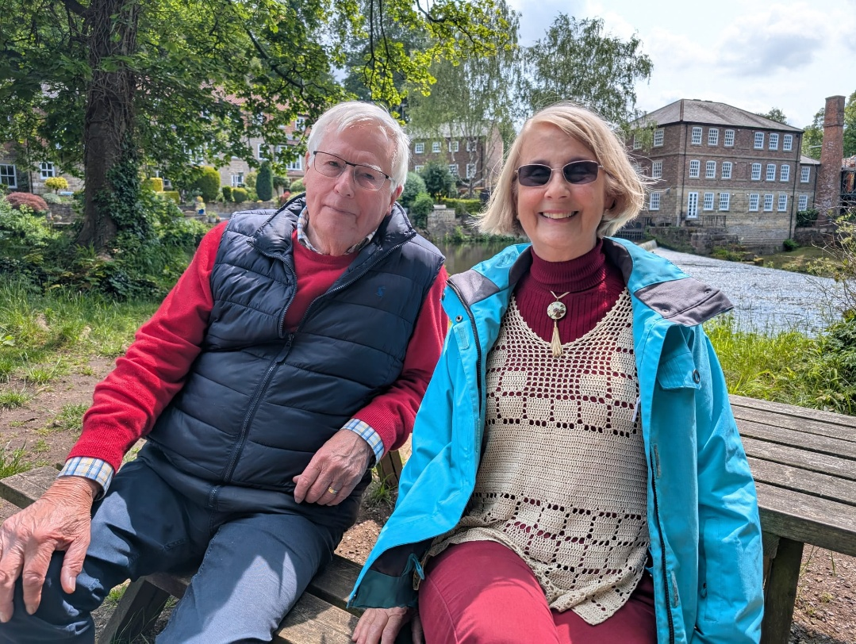
In July 2025, the BBC’s ‘Countryfile’ team arrived in Knaresborough to film a feature centred on the River Nidd, which flows through the heart of the town. Presenter John Craven was joined by Yorkshire Blue Badge Guide, Margy Longhurst, who shared insights into the river’s historical significance. The River Nidd played a vital role in the development of the local linen industry, providing employment along its banks from the thirteenth century. Knaresborough’s reputation grew to the extent that it became the sole supplier of household linen to Queen Victoria, and in 1851, the town was awarded a Prince Albert’s Medal for producing an extraordinary seamless linen shirt.
The interview was conducted at Mother Shipton’s Estate, a site steeped in legend. The BBC crew included filming at the Petrifying Well, famous for its waterfall that gradually turns everyday objects into stone. This remarkable natural phenomenon is located next to the cave where the legendary prophetess Mother Shipton is said to have lived during Tudor times.
John Craven, a proud Yorkshireman, born in Leeds and educated in Harrogate, has been a familiar face on British television since joining the BBC in 1970. From 1972 to 1989, he was the host of the children’s news programme ‘Newsround’, originally titled ‘John Craven’s Newsround’. The Knaresborough episode of Countryfile was broadcast on 17th August, the day after John’s 85th birthday.
During their conversation, Margy Longhurst was amused to learn that John Craven had previously left a sock at the Petrifying Well, which has since become petrified and is now displayed alongside a hat once belonging to John Wayne and a handbag left by Agatha Christie. Margy described John as highly professional and congenial, and considered it an honour to have been interviewed by him.

